Deerwalk Institute Of Technology
Database Administration

Lab: 5

Submitted By: Submitted To:
Name: Sagar Giri Narayan Chalise
Roll No. 205
Date:
Profile Management in ORACLE

<DESCRIPTION>

Steps to assign a role to a user in oracle:

1. Create a profile using following statement:

CREATE PROFILE <profile_name> LIMIT CONSTRAINTS <number>;

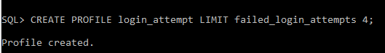
2. Create a user with a profile associate with it using following statement:

CREATE USER <user_name> PROFILE <profile_name> IDENTIFIED BY <password>

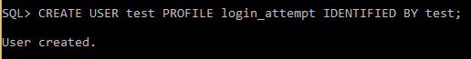
3. Try to connect to the newly created user with wrong password for 4 times:
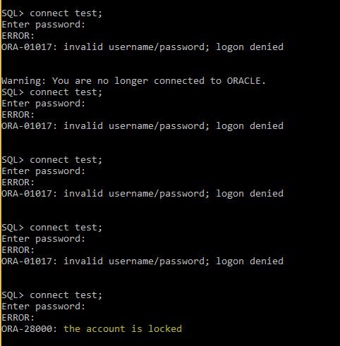

After 4 attempts (the limit we've set) the account of the user with new profile associated with it will be blocked.

To unlock the account, we fire another statement, which unlocks the user's account. The statement is:

ALTER USER <user_name> ACCOUNT UNLOCK;
